@AbapCatalog.viewEnhancementCategory: [#NONE]

@AccessControl.authorizationCheck: #NOT_REQUIRED

@EndUserText.label: 'Fiori Elements'

@Metadata.ignorePropagatedAnnotations: true

@ObjectModel.usageType:{

serviceQuality: #X,

sizeCategory: #S,

dataClass: #MIXED

}

@UI.headerInfo: {

typeName: 'Connection',

typeNamePlural: 'Connections',

title: {

type: #STANDARD,

value: 'AirlineName'

},

description: {

type: #STANDARD,

value: 'CarrierId'

}

}

@Search.searchable: true

**define** **root** **view** **entity** ZAKP_FIORI_ELEMENTS

**as** **select** **from** /dmo/connection

**association** **[**1**]** **to** ZAKP_FIORI_CARRIER **as** _carrier **on** **$projection.**CarrierId **=** _carrier**.**CarrierId

**association** **[*]** **to** ZAKP_FIORI_FLIGHT **as** _flight **on** **$projection.**CarrierId **=** _flight**.**CarrierId

**and** **$projection.**ConnectionId **=** _flight**.**ConnectionId

**{**

@UI.facet: [

{

id: 'Connections',

type : #IDENTIFICATION_REFERENCE,

label: 'ConnectionDetails',

position : 10

},

{

id: 'Flight',

type : #LINEITEM_REFERENCE,

label: 'FlightDetails',

position: 20,

targetElement: '_flight'

}]

@UI.lineItem: [{ position: 11 , label: 'AirlineId' }]

@UI.identification: [{ position: 11 , label: 'AirlineId' }]

@ObjectModel.text.element: [ 'AirlineName' ]

@UI.textArrangement: #TEXT_FIRST

@UI.selectionField: [{ position: 10 }]

@Consumption.valueHelpDefinition:

[{

entity.element: 'CarrierId' ,

entity.name: 'ZAKP_FIORI_VH_CARRIER'

}]

**key** carrier_id **as** CarrierId**,**

@UI.lineItem: [{ position: 20 , label: 'ConnectionId' }]

@UI.identification: [{ position: 20 , label: 'ConnectionId' }]

@UI.selectionField: [{ position: 11 }]

@Consumption.valueHelpDefinition:

[{

entity.element: 'ConnectionID' ,

entity.name: 'ZAKP_FIORI_VH_CONNECTIONS'

}]

**key** connection_id **as** ConnectionId**,**

// @UI.lineItem: [{ position: 10 , label: 'AirlineName' }]

@Search.defaultSearchElement: true

@Search.fuzzinessThreshold: 0.7

_carrier**.**Name **as** AirlineName**,**

@UI.lineItem: [{ position: 30 , label: 'AirportFrom' }]

@UI.identification: [{ position: 30 , label: 'AirportFrom' }]

airport_from_id **as** AirportFromId**,**

@UI.lineItem: [{ position: 40 , label: 'AirportTo' }]

@UI.identification: [{ position: 40 , label: 'AirportTo' }]

airport_to_id **as** AirportToId**,**

@UI.lineItem: [{ position: 50 , label: 'DepartureTime' }]

@UI.identification: [{ position: 50 , label: 'DepartureTime' }]

departure_time **as** DepartureTime**,**

@UI.lineItem: [{ position: 60 , label: 'ArrivalTime' }]

@UI.identification: [{ position: 60 , label: 'ArrivalTime' }]

arrival_time **as** ArrivalTime**,**

@UI.lineItem: [{ position: 70 , label: 'Distance' }]

@UI.identification: [{ position: 70 , label: 'Distance' }]

distance **as** Distance**,**

_flight

**}**

Value Helps: 1

@AbapCatalog.viewEnhancementCategory: [#NONE]

@AccessControl.authorizationCheck: #NOT_REQUIRED

@EndUserText.label: 'Basic flight tbales'

@Metadata.ignorePropagatedAnnotations: true

@ObjectModel.usageType:{

serviceQuality: #X,

sizeCategory: #S,

dataClass: #MIXED

}

@UI.chart: [{

chartType: #DONUT,

qualifier: 'OccupiedPer',

measures :['OccupiedPerc'],

measureAttributes: [{

measure: 'OccupiedPerc' ,

role : #AXIS_1,

asDataPoint: true}]

}]

**define** **view** **entity** ZAKP_FIORI_FLIGHT

**as** **select** **from** /dmo/flight

**{**

@UI.facet: [

{ id : 'FlightDetails',

label: 'FlightDetails',

position: 10,

type: #IDENTIFICATION_REFERENCE,

purpose: #STANDARD }

]

@UI.lineItem: [{ position: 11 , label: 'CarrierId' }]

@UI.identification: [{ position: 11 , label: 'CarrierId' }]

**key** carrier_id **as** CarrierId**,**

@UI.lineItem: [{ position: 12 , label: 'ConnectionId' }]

@UI.identification: [{ position: 12 , label: 'ConnectionId' }]

**key** connection_id **as** ConnectionId**,**

@UI.lineItem: [{ position: 13 , label: 'Flightdate' }]

@UI.identification: [{ position: 13 , label: 'Flightdate' }]

**key** flight_date **as** FlightDate**,**

@Semantics.amount.currencyCode: 'CurrencyCode'

@UI.lineItem: [{ position: 14, label: 'Fare' }]

@UI.identification: [{ position: 14, label: 'Fare' }]

price **as** Price**,**

currency_code **as** CurrencyCode**,**

@UI.lineItem: [{ position: 15 , label: 'PlaneType' }]

@UI.identification: [{ position: 15 , label: 'PlaneType' }]

plane_type_id **as** PlaneTypeId**,**

@UI.lineItem: [{ position: 15 , label: 'PlaneType' }]

@UI.identification: [{ position: 15 , label: 'PlaneType' }]

seats_max **as** SeatsMax**,**

**case**

**when** seats_max **>=** 300 **then** 3 //Green

**when** seats_max **>=** 200 **then** 2 //Orange

**else** 1 //Red

**end** **as** Criticality**,**

@UI.lineItem: [{ position: 17 , label: 'SeatsOccupied' ,type : #AS_DATAPOINT }]

@UI.identification: [{ position: 17 , label: 'SeatsOccupied'}]

@UI.dataPoint:{ visualization: #PROGRESS, targetValueElement: 'SeatsMax' , criticality: 'Criticality'}

seats_occupied **as** SeatsOccupied**,**

@UI.lineItem: [{ position: 18 , label: 'Occupied%' ,type : #AS_CHART ,valueQualifier: 'OccupiedPer' }]

@UI.dataPoint:{

criticalityCalculation: {

deviationRangeLowValue: 50.00,

toleranceRangeLowValue: 75.00,

improvementDirection: #MAXIMIZE

}

}

@UI.identification: [{ position: 18 , label: 'Occupied%'}]

division**(**seats_occupied**,** seats_max **,** 2 **)\***100 **as** OccupiedPerc

**}**

Case : 2

@AbapCatalog.viewEnhancementCategory: [#NONE]

@AccessControl.authorizationCheck: #NOT_REQUIRED

@EndUserText.label: 'Value Help for carrier'

@Metadata.ignorePropagatedAnnotations: true

@ObjectModel.usageType:{

serviceQuality: #X,

sizeCategory: #S,

dataClass: #MIXED

}

**define** **view** **entity** ZAKP_FIORI_VH_CARRIER **as** **select** **from** /dmo/carrier

**{**

**key** carrier_id **as** CarrierId**,**

name **as** CarrierName

**}**

@AbapCatalog.viewEnhancementCategory: [#NONE]

@AccessControl.authorizationCheck: #NOT_REQUIRED

@EndUserText.label: 'VH for COnnecctiojs'

@Metadata.ignorePropagatedAnnotations: true

@ObjectModel.usageType:{

serviceQuality: #X,

sizeCategory: #S,

dataClass: #MIXED

}

@ObjectModel.resultSet.sizeCategory: #XS

**define** **view** **entity** ZAKP_FIORI_VH_CONNECTIONS

**as** **select** **from** /dmo/connection

**{**

**key** connection_id **as** ConnectionID**,**

carrier_id **as** CarrierID

**}**

@AbapCatalog.viewEnhancementCategory: [#NONE]

@AccessControl.authorizationCheck: #NOT_REQUIRED

@EndUserText.label: 'View on Carrier table'

@Metadata.ignorePropagatedAnnotations: true

@ObjectModel.usageType:{

serviceQuality: #X,

sizeCategory: #S,

dataClass: #MIXED

}

**define** **view** **entity** ZAKP_FIORI_CARRIER

**as** **select** **from** /dmo/carrier

**{**

**key** carrier_id **as** CarrierId**,**

name **as** Name**,**

currency_code **as** CurrencyCode**,**

local_created_by **as** LocalCreatedBy**,**

local_created_at **as** LocalCreatedAt**,**

local_last_changed_by **as** LocalLastChangedBy**,**

local_last_changed_at **as** LocalLastChangedAt**,**

last_changed_at **as** LastChangedAt

**}**

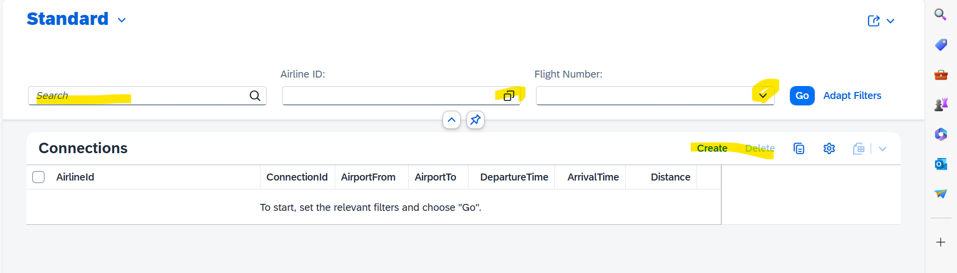

Search field

Value Help

Drop Down

List Display

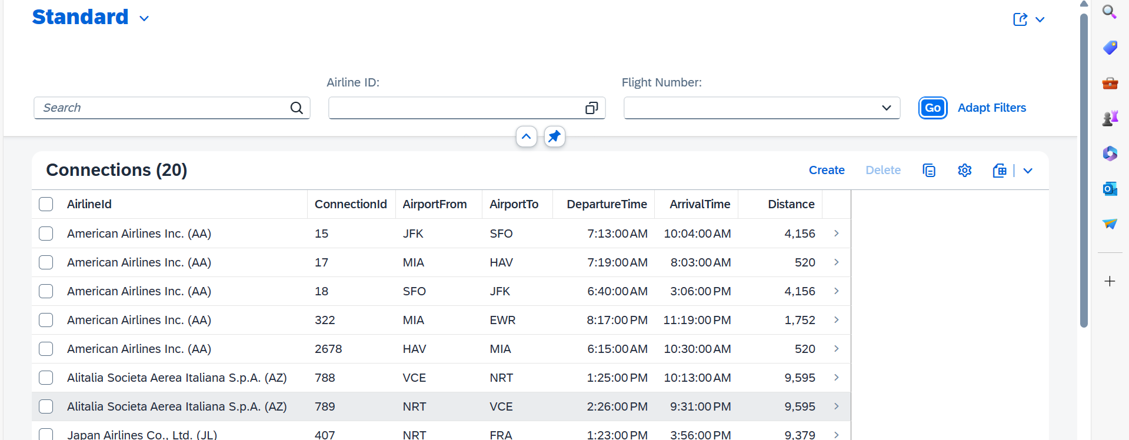

**Object Page ,**

**Identification and List**

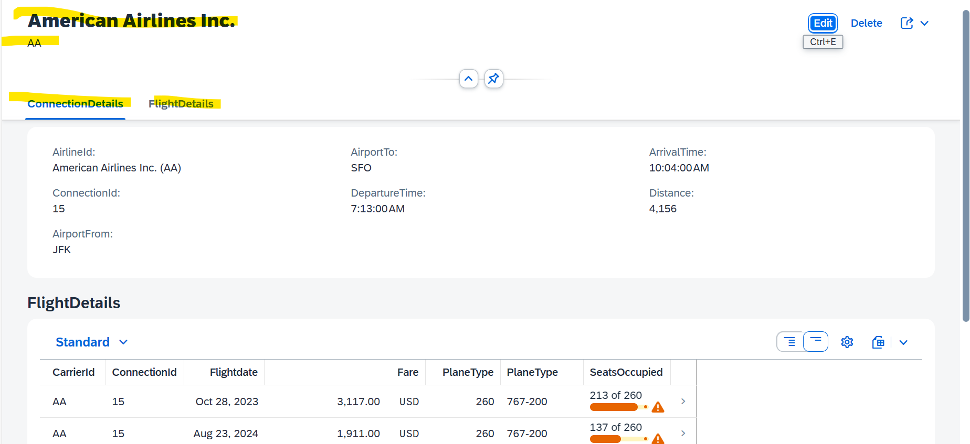

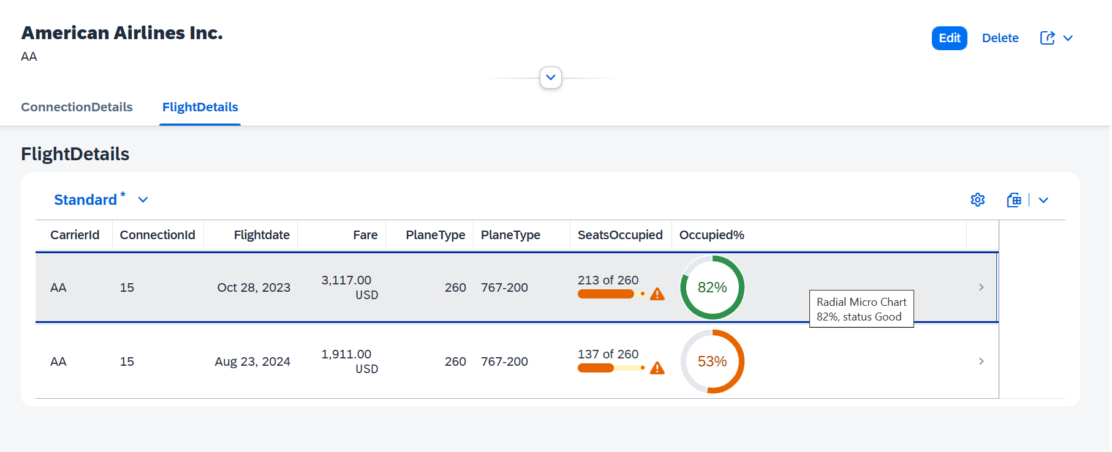

**Object Page from Flights details:**

